SIMATS ENGINEERING (SAVEETHA SCHOOL OF ENGINEERING)
Department of Artificial Intelligence and Machine Learning

ASSESSMENT 2 – Industry Problem Task (5 QUESTIONS)

Course Code: | MLA0407 | Course Title: | Deep Learning  Assessment 2: Industry  Problem Task  (5 Questions × 10 Marks)
CO Assessed: | CO3 | Assessment:
Weightage: | 35% of CIA | Total Marks:
CO1 Statement: | Apply the fundamental concepts of machine learning and neural networks to design and analyze learning algorithms using perceptrons, multilayer perceptrons, forward propagation, backpropagation, gradient descent optimization techniques, and Maximum Likelihood Estimation for solving real-world problems.
Student Name: | I. Leela Sravan Kumar | Reg. No.: | 192425272  29.08.2026
Section / Batch: | AIML(2024) | Date:

Code of Conduct
I I. Leela Sravan Kumar (192425272) (NAME/ REG NO) certify that this submission is my original work and
that I have adhered to the guidelines specified for this assessment. I understand that any violation of academic integrity rules will result in disciplinary action. Signature of the Student:

QUESTIONS: 5 Total Marks: 50

Annexure A

Industry Problem Task

1. Industrial Defect Detection
A manufacturing company wants to automatically identify defective products from conveyor belt images. Design a transfer learning-based defect detection/classification solution using DenseNet or another suitable pre-trained CNN. Explain your model selection, feature extraction, fine-tuning strategy, and evaluation metrics.

2. Medical Diagnosis Support System
A hospital wants an AI system to assist doctors in identifying diseases from medical images. Develop a deep learning solution using transfer learning for medical image classification. Compare feature extraction and fine-tuning approaches and justify the final model.

- Customer Review Sentiment Analysis
An e-commerce company receives thousands of customer reviews every day and wants to automatically understand customer sentiment. Design an RNN/LSTM/BiRNN-based sentiment analysis system to classify reviews as positive, negative, or neutral.

- Predictive Text for a Mobile Application
A mobile keyboard company wants to provide intelligent next-word suggestions. Develop an LSTMbased next-word prediction model and explain how sequential data is processed using BPTT and how LSTM handles long-term dependencies.

5. Automated Customer Support
A multinational company wants to automatically translate customer queries between languages. Design an Encoder–Decoder-based Sequence-to-Sequence model for machine translation. Explain the role of the encoder, decoder, and sequence representation.

6. Social Media Content Monitoring
A social media platform wants to automatically classify posts based on sentiment or category. Develop and compare RNN, BiRNN, and LSTM models for the problem. Analyze which architecture is most suitable for understanding contextual information.

- Agriculture Crop Disease Detection
An agricultural technology company wants to identify crop diseases from leaf images submitted by farmers. Develop a transfer learning-based image classification system using DenseNet. Apply data augmentation, feature extraction, and fine-tuning to improve performance.

- Financial News Analysis
A financial organization wants to analyze news headlines and predict whether the market sentiment is positive, negative, or neutral. Design an LSTM or BiRNN-based sequential learning model and compare its performance with a basic RNN.

9. Automated Document Processing
A company receives a large number of scanned documents and wants to automatically classify them into categories such as invoices, resumes, reports, and contracts. Design a deep learning-based document classification system using transfer learning. Discuss preprocessing, feature extraction, model development, and fine-tuning.

10. Smart Traffic Monitoring
A smart city project wants to classify images captured from traffic cameras into categories such as cars, buses, motorcycles, and emergency vehicles. Develop a transfer learning-based traffic classification model using a pre-trained DenseNet architecture and optimize it for real-time deployment.

SOCIAL MEDIA CONTENT MONITORING

Problem
A social media platform wants to automatically classify posts based on sentiment or category using RNN, BiRNN and LSTM.

Answer
The text is first converted into numerical sequences using tokenization and word embeddings. Then different sequential models are trained and compared.

Architecture
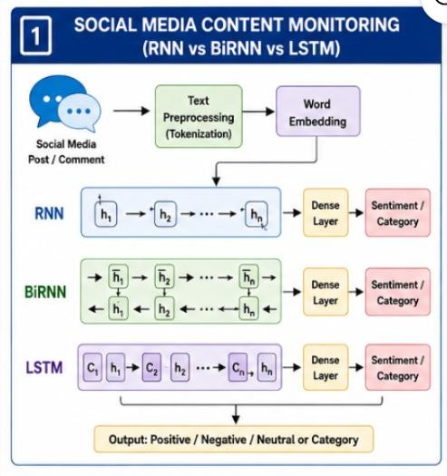
RNN
Processes text from left to right and remembers previous words.
BiRNN
Processes text in both directions, so it uses past and future context.

LSTM
Uses memory cells and gates to remember important information for longer sequences. Comparison
Model Context | Long-Term Memory
RNN Past | Low
BiRNN Past + Future | Medium
LSTM Sequential context High

Conclusion
LSTM or BiRNN is generally more suitable than basic RNN for understanding contextual information. LSTM is especially useful for long posts because it handles long-term dependencies better.

AGRICULTURE CROP DISEASE DETECTION
Problem Identify crop diseases from leaf images using transfer learning with DenseNet. Answer
A pre-trained DenseNet can be used to extract important visual features from crop leaf images.

Architecture
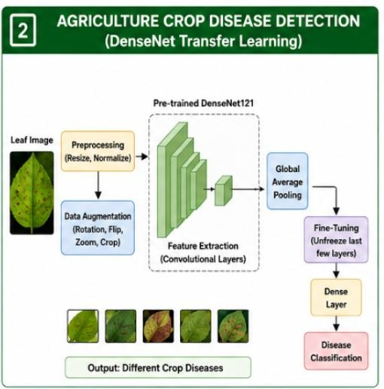

Preprocessing
- Resize images
- Normalize pixel values
- Remove corrupted images
- Split into training, validation and testing sets Data Augmentation Apply:
- Rotation
- Flipping
- Zooming
- Cropping
This increases data variety and reduces overfitting.

Feature Extraction
Initially, DenseNet layers are frozen and used to extract features such as:
Edges → Textures → Leaf Patterns → Disease Features

Fine-Tuning
The last few DenseNet layers are unfrozen and trained with a small learning rate so that the model adapts to crop disease patterns.

Evaluation
Use:
- Accuracy
- Precision
- Recall
- F1-score
- Confusion Matrix

Conclusion
DenseNet with augmentation, feature extraction and fine-tuning can provide accurate crop disease detection while reducing training time.

FINANCIAL NEWS ANALYSIS

Problem
Predict whether financial news sentiment is positive, negative or neutral using LSTM/BiRNN and compare it with a basic RNN.

Answer
Financial headlines are sequential text, so an LSTM or BiRNN can learn relationships between words and predict market sentiment.

Architecture
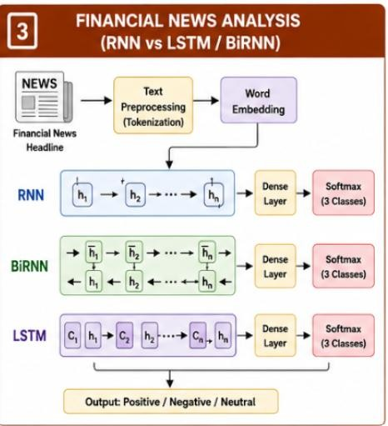

Basic RNN
Text → Embedding → RNN → Dense → Softmax
RNN can capture short-term dependencies but may struggle with long-term relationships.

LSTM
LSTM uses gates to control information:
Input → LSTM → Memory → Dense → Sentiment
It can retain important information for longer sequences.

Comparison
RNN | LSTM/BiRNN
Simple architecture | More advanced
Short-term context | Better contextual learning
Faster | More computationally expensive
Vanishing-gradient problem | LSTM reduces this problem

Conclusion
LSTM/BiRNN is preferred because financial headlines may contain important relationships between words that are separated in the sentence.

AUTOMATED DOCUMENT PROCESSING
Problem Classify scanned documents into invoices, resumes, reports and contracts using transfer learning. Answer
Transfer learning can use a pre-trained CNN to extract visual features from scanned documents.

Architecture
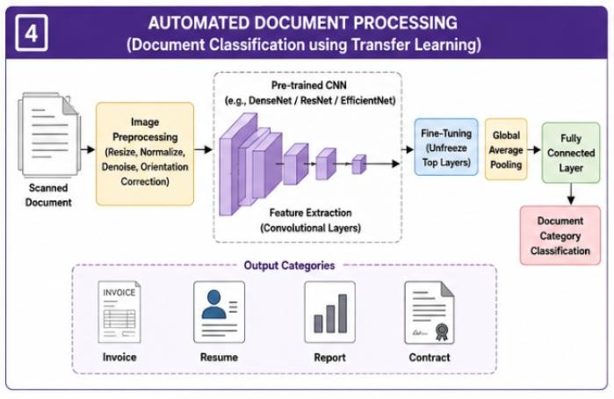

Preprocessing
- Convert scanned pages into images
- Resize images
- Normalize pixel values
- Remove noise
- Correct image orientation

Feature Extraction
The pre-trained CNN learns:
Edges → Text Layout → Tables → Document Patterns

Model Development
- Load a pre-trained CNN.
- Remove the original classifier.
- Add new classification layers.
- Freeze the base layers.
- Train the new classifier.
- Unfreeze selected layers.
- Fine-tune using a low learning rate.

Output
Document
↓
┌─────┼─────┬──────┐
↓ ↓ ↓ ↓
Invoice Resume Report Contract Evaluation Use:
- Accuracy
- Precision
- Recall
- F1-score
- Confusion Matrix

Conclusion
Transfer learning reduces training requirements and allows the system to automatically classify different document types based on their visual and structural features.

SMART TRAFFIC MONITORING

Problem
Classify traffic-camera images into cars, buses, motorcycles and emergency vehicles using a pre-trained DenseNet and optimize it for real-time deployment. Answer
A pre-trained DenseNet can be used to extract vehicle features and classify traffic images.

Architecture
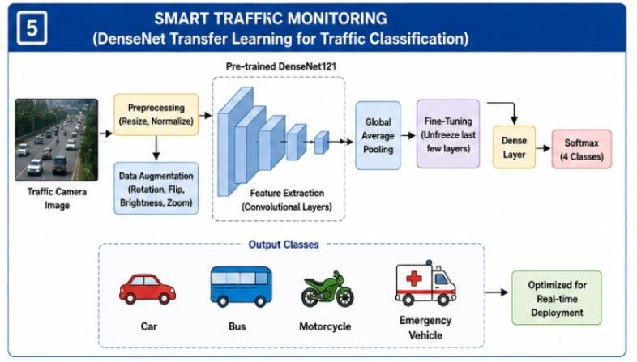

Classes
Image
↓
┌───────┼────────┐
↓ ↓ ↓
Car Bus Motorcycle
↓
Emergency Vehicle

Training
- Collect traffic images.
- Resize and normalize images.
- Apply augmentation.
- Load pre-trained DenseNet.
- Freeze initial layers.
- Train the classification layer.
- Fine-tune deeper layers.
- Evaluate the model.

Real-Time Optimization
To achieve faster prediction:
- Use a smaller input image size.
- Use batch processing where appropriate.
- Remove unnecessary layers.
- Use model quantization.
- Use GPU/edge hardware.
- Optimize the trained model for inference. Evaluation Use:
- Accuracy
- Precision
- Recall
- F1-score
- Inference time
For real-time systems, inference speed is very important.

Conclusion
DenseNet transfer learning provides strong feature extraction, while fine-tuning improves traffic-specific classification. Model optimization helps achieve accurate and fast real-time vehicle detection.

Rubrics for Calculation

Criteria | Weightage | Level 4 (Exemplary) | Level 3 (Proficient) | Level 2 (Developing) | Level 1 (Beginning)
Technical Content  Accuracy | 30 | Highly accurate, indepth, and  insightful technical explanation | Technically correct content  with adequate depth and clarity | Basic concepts presented with  limited accuracy and depth | Content contains major technical  errors; concepts poorly understood
Problem  Identification | 25 | Problem rigorously analyzed using  appropriate and advanced methods | Problem clearly defined with a logical  engineering approach | Problem  identified but analysis or  methodology is weak | Problem statement unclear or incorrect; no logical approach
Use of Tools | 20 | Advanced tools, wellanalyzed data, and highly effective visuals | Appropriate tools and data  used effectively with clear visuals | Limited use of tools and basic data  interpretation | Minimal or incorrect use of tools and data; poor visuals
Communication | 15 | Highly engaging, confident, and  audience-focused delivery | Clear, organized, and professional communication | Understandable but lacks clarity, structure, or confidence | Poor organization,  unclear speech, ineffective slides
Professionalism | 10 | Exemplary professionalism, leadership, and ethical awareness | Professional conduct with  effective team collaboration | Basic professionalism;  uneven team participation | Lacks professionalism; minimal  contribution or ethical  awareness

Faculty In-charge | Course Coordinator | Program Director
Signature: | Signature: | Signature:
Date: | Date: | Date:

